**Industrial Work**

**Report**

**On**

**Weekly Project Work**

|  |  |
| --- | --- |
| Developed By: - | Guided By:- |
| Krupal Patel (20162121007) | Prof. Aniket Patel (Internal) |
|  | Mr. Jignesh Patel (External) |

**Submitted to**

**Faculty of Engineering and Technology**

**Institute of Computer Technology**

**Ganpat University**



**Year – 2024**

**INTERNSHIP CERTIFICATE**

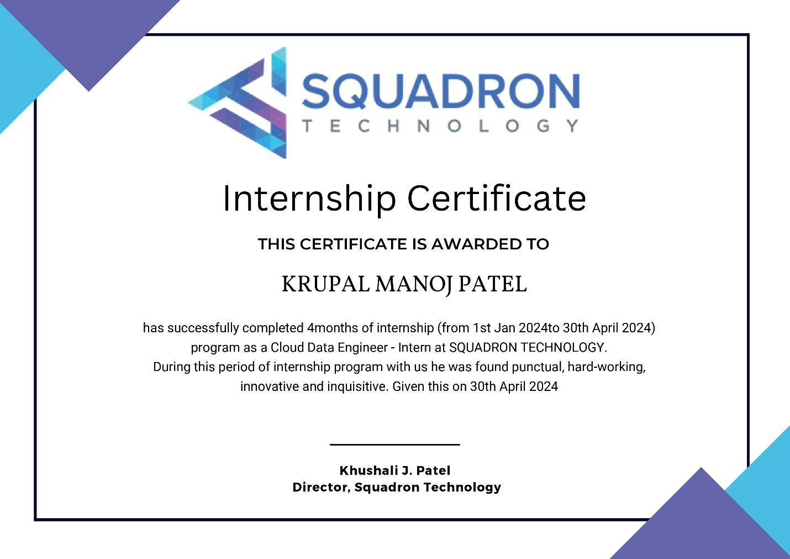

**ACKNOWLEDGEMENT**

IBM/Industry Internship is a golden opportunity for learning and self-development. I consider myself very lucky and honored to have so many wonderful people lead me through in completion of this project. First and foremost, I would like to thank Dr. Rohit Patel, Principal, ICT, and Prof. Dharmesh Darji , Head, ICT who gave us an opportunity to undertake this project. My grateful thanks to Prof. Aniket Patel & Mr. Jignesh Patel (Internal & External Guides) for their guidance in project work Predicting Application Rating of Google Play Store, who despite being extraordinarily busy with academics, took time out to hear, guide and keep us on the correct path. We do not know where would have been without his/her help. CSE department monitored our progress and arranged all facilities to make life easier. We choose this moment to acknowledge their contribution gratefully.

Krupal Patel (20162121007)

**TABLE OF CONTENT**

**Title PageNo**

**INTRODUCTION TO JOB ROLE 1**

**WEEK I 2**

**WEEK II 3**

**WEEK III 4**

**WEEK IV 5**

**WEEK V 6**

**WEEK VI 7**

**WEEK VII 8**

**WEEK VIII 9**

**WEEK IX 11**

**WEEK X 13**

**WEEK XI 14**

**WEEK XII 15**

**WEEK XIII 16**

**WEEK XIV 17**

**WEEK XV 18**

**WEEK XVI 19**

**CONCLUSION 20**